FOCP C Programming Assignment
Question 2: Solve Me First
Platform: HackerRank
Programming Language: C
Problem Statement URL:
https://www.hackerrank.com/challenges/solve-me-first/problem
Problem Statement
Complete the solveMeFirst function to compute the sum of two integers, a and b. Return the sum of the two integers.
Source Code
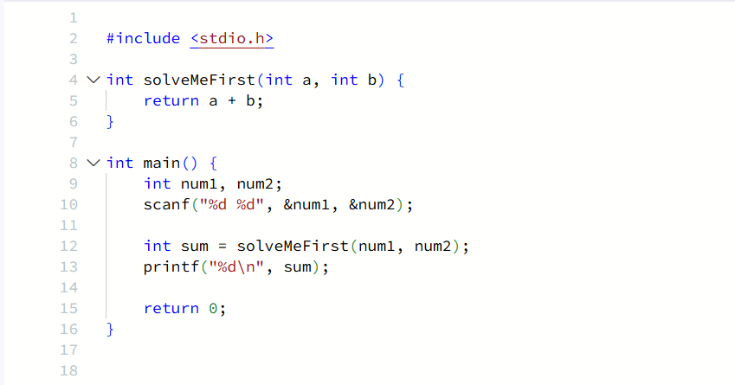Output
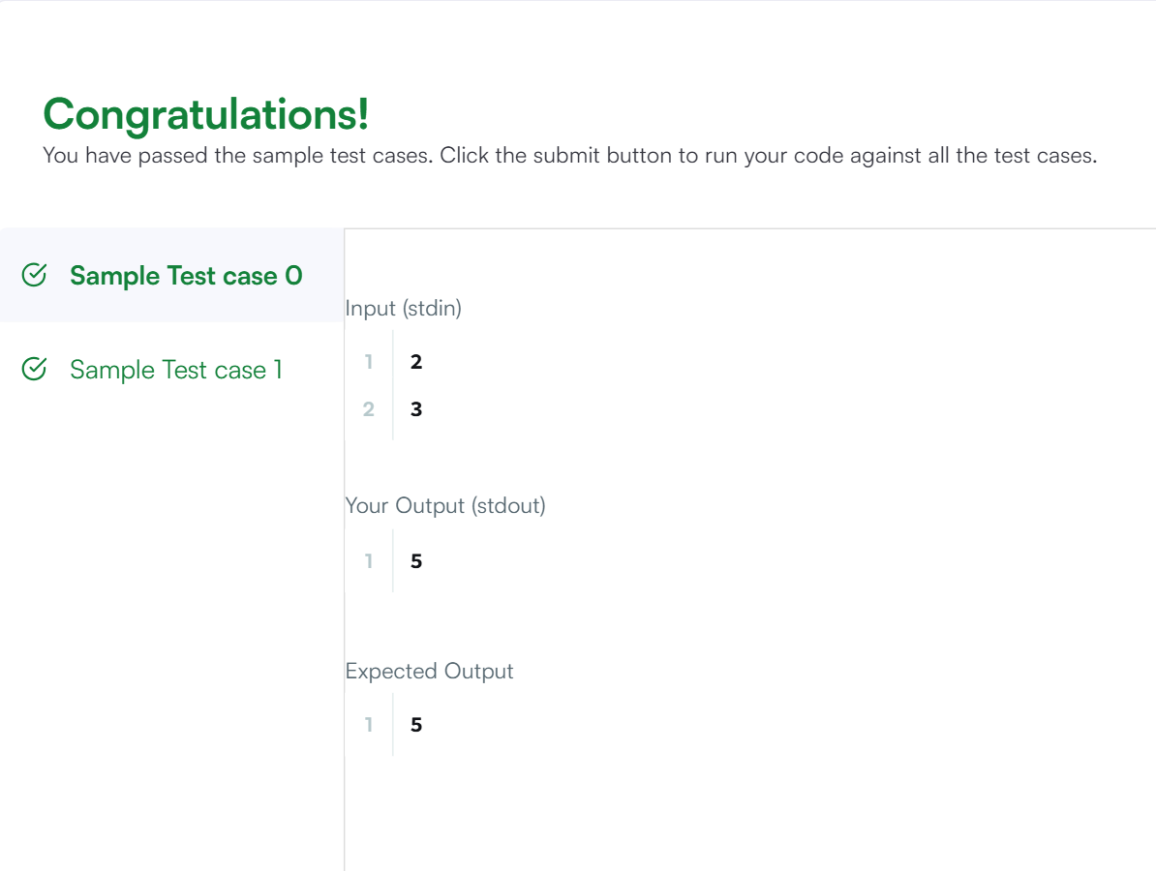
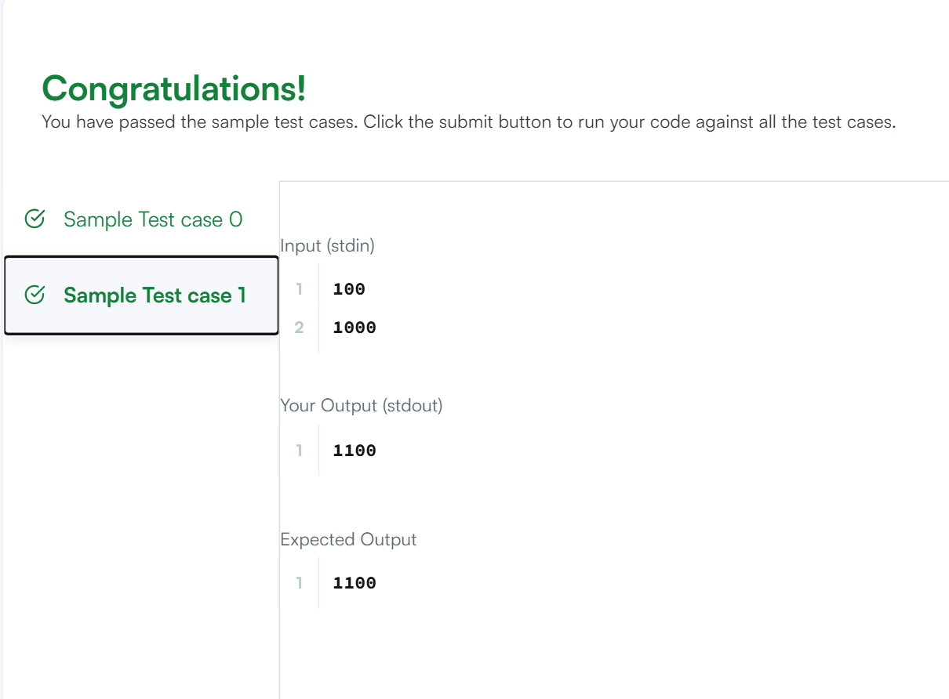
Result
The program was executed successfully, and the submission was accepted on HackerRank.

